**Generative AI Use Statement**

**Part 1 Disclosure Statement: Please check all boxes that apply.**

I did not use generative AI tools in creating this paper. 🞏

or

I did use generative AI tools in creating this paper, namely ______*ChatGPT*_______________________________ (*ChatGPT*, *Grammarly*, *Google Translate*, etc.). I used it in the following ways (check which of the following acceptable uses were utilized):

* Brainstorming 🞏
* Generating ideas/topics/research questions 🗹
* Outlining help 🞏
* Language/grammar/spelling/punctuation/mechanics help 🗹
* Others 🞏 (Please be specific):

and

* I affirm I did not generate text with artificial intelligence and directly copy it into my paper. 🞏
* I affirm I have checked the information (e.g. evidence, examples, sources of research) provided by AI to avoid misinformation used in writing. 🞏
* I will provide a reflection on using generative AI tools in Part 2. 🗹
* I will attach screenshots of the most relevant interactions with AI in Part 3. 🞏

**Part 2 Analysis and Reflection**

1. The reasons I use AI in writing this paper include:

Generating ideas and grammar help.

1. I find using AI tools have the following pros and cons:

Pros:Convenient, fast, and efficient.

Cons:Off topic, redundant and verbose

**Part 3 Appendix (attach screenshots and/or line-by-line comparison below)**

Please attach **the most relevant** interactions with AI in each category if it applies and provide explanations how you use the information generated by AI in writing. You may write explanations in **Chinese**.

(The following examples are for your reference. In your own statement, please use your own screenshots and explanations to replace the examples below. You may use Chinese to explain how you have used the content in the screenshots in your writing).

1. Brainstorming

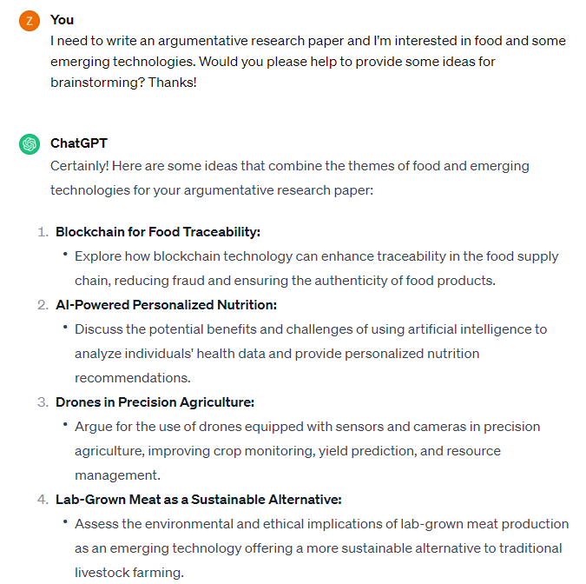

**Explanation:** I’m interested in food and some emerging technologies, so I ask ChatGPT for some ideas. When I read the idea about lab-grown meat, I remember I have read an article about artificial meat before. I find that people may use “lab-grown meat” interchangeably with “artificial meat.” Then I decide to reread the paper about artificial meat and do more research about this topic.

1. Generating a research question

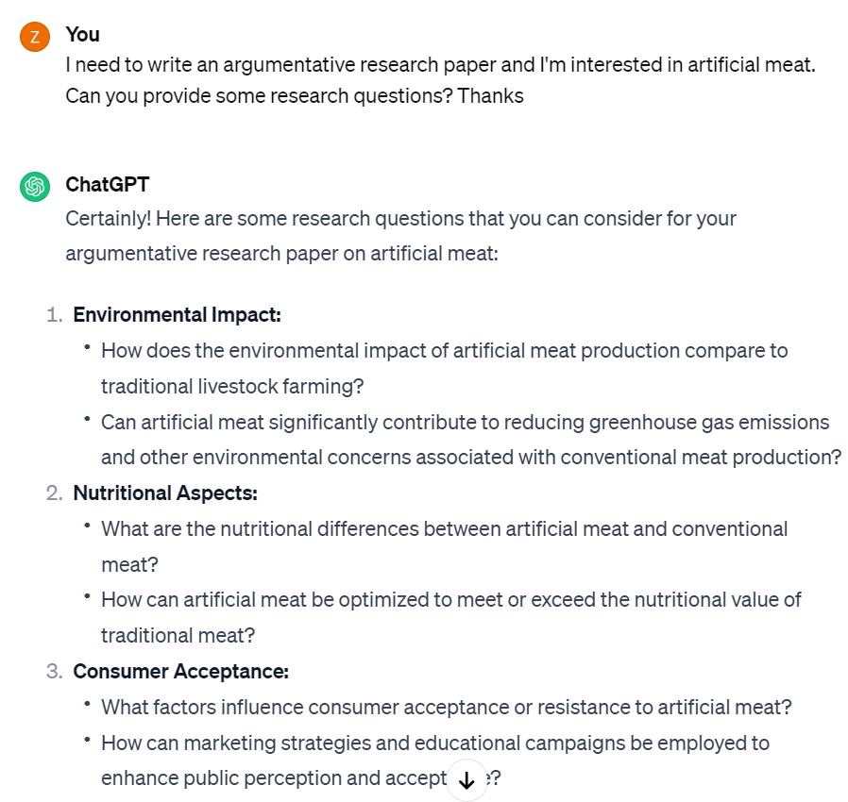

**Explanation:** I am interested in artificial meat and ask the possible research questions related to it. Based on the response given by ChatGPT, I decide to write about consumer acceptance, making research on whether artificial meat can replace conventional meat.

1. Outline help

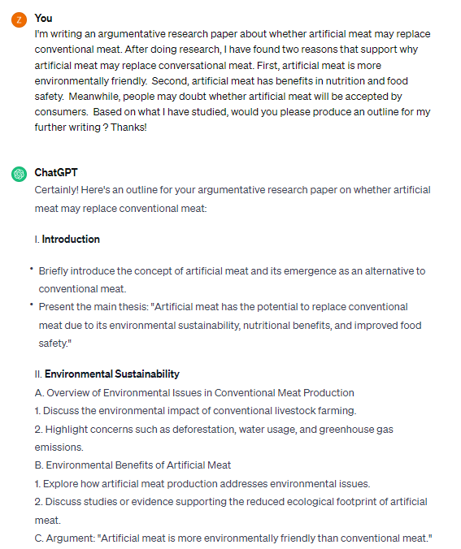

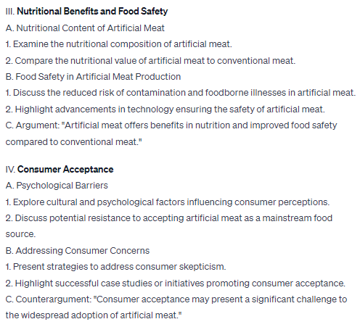

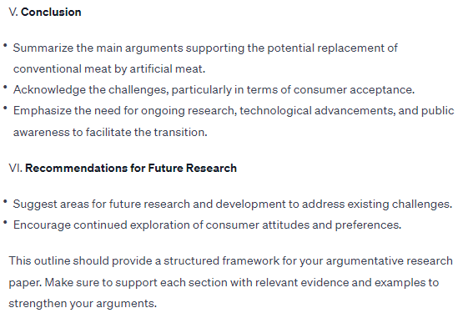

**Explanation:** After reading some articles related to my research topic, I find a few reasons why artificial meat tends to replace conventional meat. After I give my reasons to support my idea, the ChatGPT provides a very detailed outline, which is useful for framing my structure in writing. I find the counterargument mentioned by ChatGPT is most useful for my writing the counterargument paragraph. I do research about strategies to address consumer skepticism and find people are more likely to accept artificial meat if they are informed about the environmental and health benefits of it (Benny et al., 2022).

1. Language/grammar/spelling/punctuation/mechanics help

1）Language help

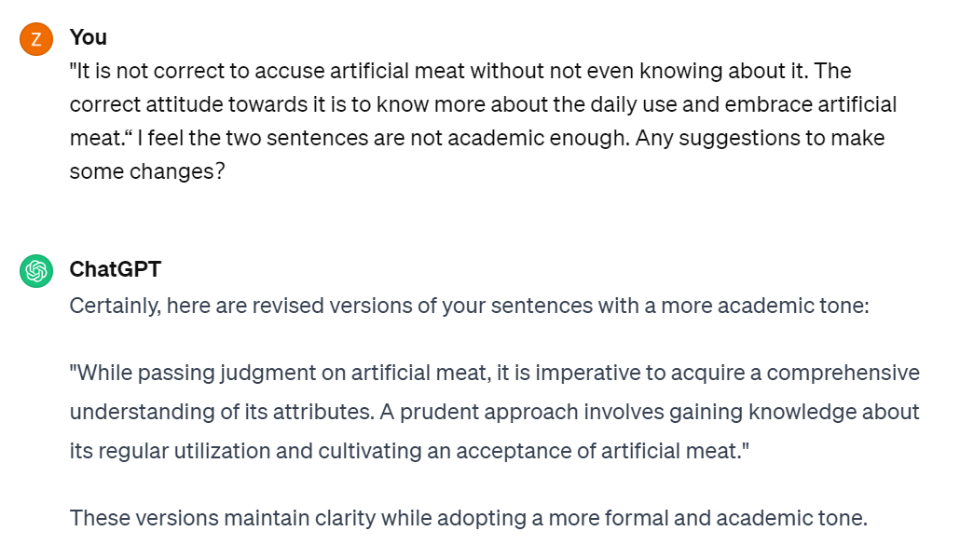

**Explanation:** I have problems writing academically, so I do ask ChatGPT for some help. However, I find the version provided by ChatGPT is too bookish, but I do find some expressions might be helpful. For example, “judgement”, “a comprehensive understanding” are phrases which exactly what I intend to say. I rewrite my sentences using the two phrases. The table below shows the comparisons:

|  |  |  |
| --- | --- | --- |
| My 1st version | Revision by ChatGPT | My 2nd version |
| *It is not correct to accuse artificial meat without not even knowing about it. The correct attitude towards it is to know more about the daily use and future development.* | *"While passing judgment on artificial meat, it is imperative to acquire a comprehensive understanding of its attributes. A prudent approach involves gaining knowledge about its regular utilization and cultivating an acceptance of artificial meat."* | *Having a comprehensive understanding of artificial meat is essential before making a judgement. A cautious perspective should be based on more research into this topic.* |

2) Grammar help

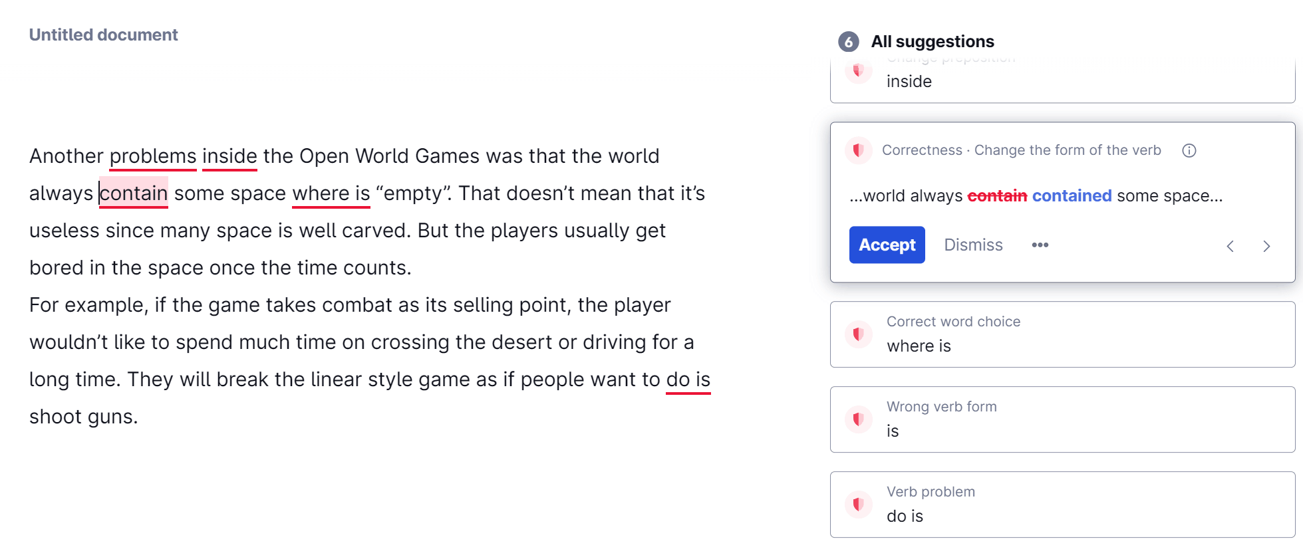

**Explanation:** I find *Grammarly* is useful in detecting my grammar errors in writing.

* 1. “Another” should be paired with a singular noun: “another problem.”
  2. “Inside” should be replaced with “in”: In not Inside the games
  3. The tense should be consistent using “contained” (past tense) and “where was” (past tense)
  4. Using “do is” incorrect because there are three verbs “do, is, shoot” in my draft. The correct way to express is “…as if people want to shoot guns.”

1. Others

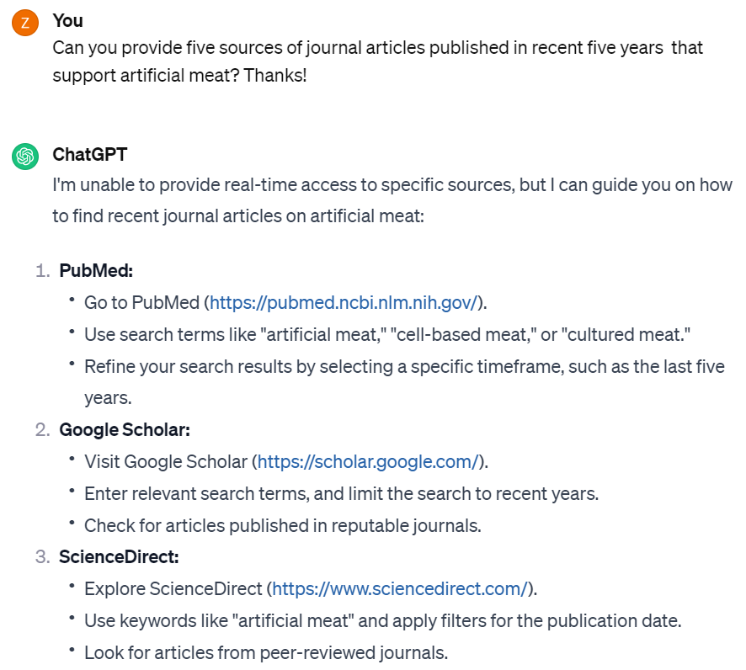

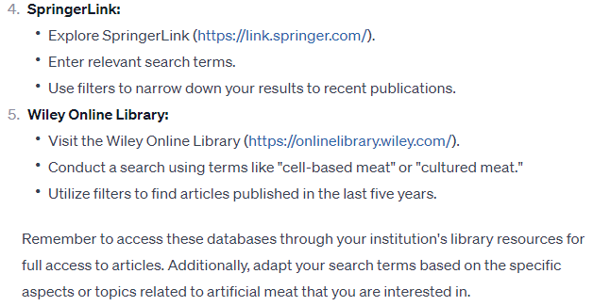

**Explanation:** I ask ChatGPT to provide some recent publications supporting artificial meat, but it fails to give any specific answers. However, the databases provided by ChatGPT are useful. For example, I get access to Wiley Online Library using SUSTech’s online library and find it’s very helpful to find the relevant articles. For example, the three articles (Bekker et al.,2017; Benny et al., 2022; Tuomisto & Teixeira, 2011) are found in Wiley.

**Notes:**

The AI disclosure statement is adapted from the syllabus policy for AI of “First Year Writing” by Loretta Notareschi at *Regis University* (*Syllabi Policies for AI Generative Tools* <https://docs.google.com/document/d/1RMVwzjc1o0Mi8Blw_-JUTcXv02b2WRH86vw7mi16W3U/edit> )

The appendix is adapted from the generative AI assistance (GAIA) policy of “Computing & Data Sciences” at Boston University (*Syllabi Policies for AI Generative Tools* <https://docs.google.com/document/d/1RMVwzjc1o0Mi8Blw_-JUTcXv02b2WRH86vw7mi16W3U/edit> )

The examples in Part 3 are for your reference. You need to provide **your own screenshots and brief explanations** based on your own AI use in writing. You may write explanations in **Chinese**.